HOP-17
Episode Five

Title: HOP-17
Episode Five
Length: 34 pages
Author: ©Angela White
ISBN#: 978-1-945927-59-1

All rights reserved worldwide. No part of this publication may be replicated, redistributed, or given away in any form without the prior written consent of Angela White.

TOC

Episode Five
Contact Author

Episode Five

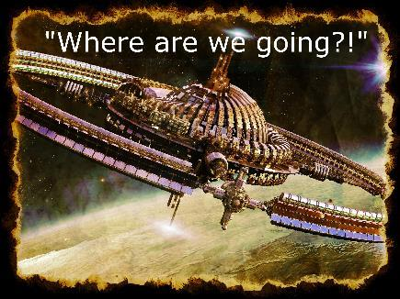
Jerald pointed over the rear of the pod as they breached the atmosphere of the station.
“No way!”
Jerald ignored her, bracing as the pod flew toward the sewer opening.
“Gross!” Amanda held on as they blasted into the muck and vanished.
Jerald tried to steer, but it was impossible to see. The pod pinged off sides and edges, finally slamming to a halt on a platform a few feet above the muck line.
Both passengers breathed through their mouths until their guts would allow normal intake. The smell was bad.
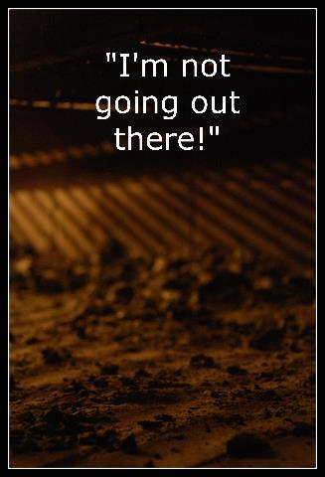
“Okay.” Jerald popped the hatch and climbed out.
Amanda grumbled as she followed him, fighting not to puke.
Jared took the worker platform to the rumbling stairs and began climbing, glad they didn’t have to get into the mess to get out of the sewer.
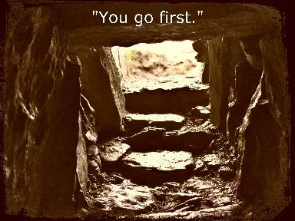
Amanda climbed fast when she realized it was an exit. She shoved by him on the slippery ladder and pushed her body out of the sewer hole, falling onto the soft brown earth.
Sunlight blinded her to the waiting people, but she heard gasps and mutters. Amanda let her eyes adjust as Jerald hurried out and stood over her.

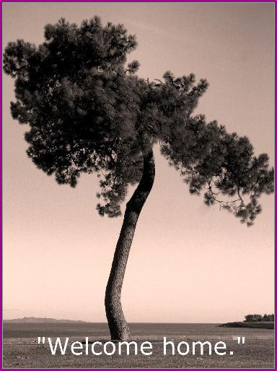
Amanda took a minute to study their surroundings and figure out exactly where they were.
Jerald stood next to her and gawked, mouth opening to express the shock he felt.
Around them, a small crowd was gathering. The witnesses pointed and muttered, but not in a threatening way.
Amanda decided on a direction, then turned to Jerald. “I think we should…” She paused, seeing his expression. “What’s wrong?”
Jared waved a jerky hand. “I don’t understand. This is supposed to be Eden station.”
Amanda frowned. “This is. You landed us in the outer poor district. We’ll have to make our way into the wealthy section so we can access the labs and engineering.”
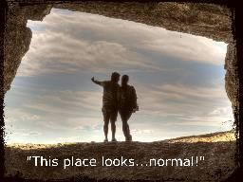
“That’s not what I mean.” He turned in a circle indicating everything around them. “I don’t understand.”

Amanda sighed, realizing he was another brainwashed lemming who believed the stories he’d been told. “Have you ever been on Eden Station?”
Jerald shook his head. “My trial was held during transport. There were a bunch of faces on a monitor. I couldn’t see much in the background.”
Amanda didn’t want to take the time to explain things to him, but it was clear he was having an epiphany moment. If she didn’t get this over with, it would interrupt everything else they did until he got it out of his system. Resigned, she nodded politely at the people watching them while she began to explain. “Eden Station is divided into three main areas. As I’m sure you know, the station itself is a cylindrical feat of engineering with outer rings.”
Jerald nodded, glad she was speaking slow so his ears would accept the words. “All residential space stations are cylindrical.”
“Yes. All stations are also separated by class.”
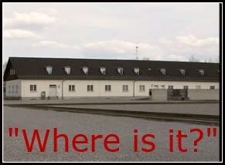
Anger came back to Jerald’s face. “That’s what I’m talking about. We’ve been told the lower classes are abused and kept in slavery conditions.” He looked around again, voice rising.
“On other stations maybe, I wouldn’t know. On Eden, it’s always been this way.” Amanda pointed. “There’s one central road that travels in an unending circle through the outer ring. That’s the poor district, where we are now. The buildings across from us are businesses. Homes line both sides of that and then farms fill out the ends. Those items are shipped by the four main roads that lead to the center of the station. The wealthy people in the middle turn those goods into supplies and materials. Some of that is then passed back to the poor districts to make products, while the rest of it is sent to labs or storage areas for later use. With me so far?”
Jerald nodded, catching about half of it in favor of studying their witnesses. The townspeople weren’t threatening, but they also weren’t friendly.
“In the very center of the station, surrounded by a nearly impenetrable wall, are two elite towers where the breeders live. Everything they need to survive is in those towers, except for the power that runs them. That’s in the wealthy industrial area we need to reach.” Amanda frowned. “You brought us down on the direct opposite of that. To get to it, we either have to stay in the poor zone all the way around the outer edge until we reach it, or we have to try to cut straight through the center and not be noticed by security.”
“We’ve been taught that this station enslaves non-breeders and forces them to work so the breeders can have an easy life.”
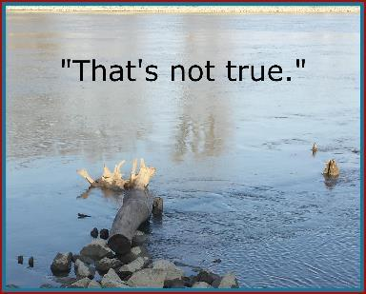
“The opposite, in fact.” Amanda’s eyes were haunted. “If you’re a breeder, you’re not allowed to leave that center area inside the wall. You’re not allowed off this station once you finish your education, ever. Then you’re forced to marry and breed. The elite council decides those matches. The men and women have no say in it. The elite are the slaves. The poor and the wealthy are not breeders. No one cares what they do.”
Jerald glanced at the poor people, aware of them nodding in response to Amanda’s explanations. It was obvious she was telling the truth. Everything he had been taught to fight was a lie.
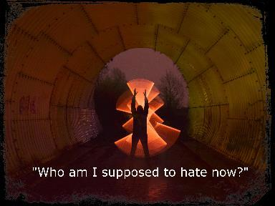
Amanda sighed. “Previous councils who made rules that encourage it. Previous citizens who voted in those rulers. Current populations who refuse to change. There are a lot of people to blame, but honestly, only the solution matters.”
Jerald forced himself to push the confusion and anger from his mind. They still had a job to do. This new information didn’t change it. “I think we should stick to the poor areas as much as we can. Maybe we can go unnoticed.”
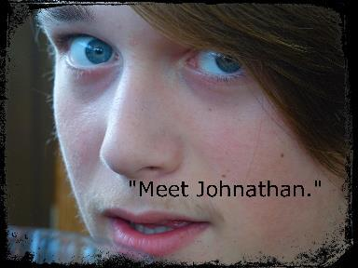
Amanda turned toward the street, nodding to the new people who had just joined the group. She recognized them. “Too late for that.”
“He is second in command of the Moderation Army.”
Half a dozen Moderation members came through the crowd to surround them with weapons and dark glowers. Their laser guns were up-to-date, and their body markings were light. They blended in well and clearly had access to the goods being produced on this station.
Jerald stepped closer to Amanda, waiting to see if this conversation would be friendly. The body language implied it would not.
“You need to come with us.” Johnathan made a motion.
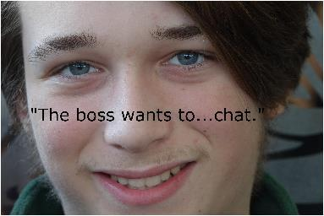
Both captives were pushed toward a storage shelter across from business row, but it wasn’t violent. These men didn’t have orders to kill them, yet.
Amanda didn’t resist, so Jerald didn’t either, but he was ready to defend them both. Against this many, he expected to lose, but so would the enemy.
“Wait in here for the boss.”
Moderation members shoved Amanda and Jerald into the warehouse. The door slammed behind them.
“The boss?”
Amanda didn’t answer, though she suspected leadership had changed. The previous leader wouldn’t have been so polite about their capture. And that’s your mistake. You guys didn’t even take our weapons.
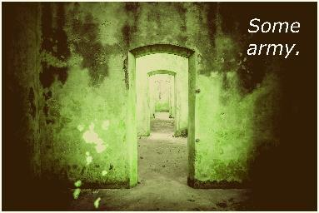
Amanda went to the chairs by the smoldering firepit in the center of the building and dropped down. She’d been expecting this, but not so soon. It only proved the suspicion that her mother had betrayed them.
Jerald took the chair across from her, full of questions. “All my life, I was told the elite people took advantage; they starve the poor and abuse them.” He glanced around, hand waving. “Where’s the starving? The whips and blood? The oppression?”
“It was never true. The Moderation Army never had the people’s interests at heart. The Mod is based on anarchist views of those who refuse to do honest work for a fair share. It’s easier to steal and stir rebellions to take down a system they don’t want to belong to.”
“They’re...freeloaders?”
“In a way. They don’t believe anyone should have to work.”
“Then where would everything come from?”
“The elite.”
“But the elite don’t produce. They pay the poor or wealthy to do that.”
“Yes, and no. Some elite do produce, but not on their own. They need workers of all classes, including their own.”
“So if the Mod gets rid of the elite, they also get rid of the workers.”
“Yes.”
“Why would they do that? Without the workers, nothing gets made.”
“They want the elite to become workers.”
“There aren’t enough elite to fill all those jobs. We also can’t force them into slavery.”
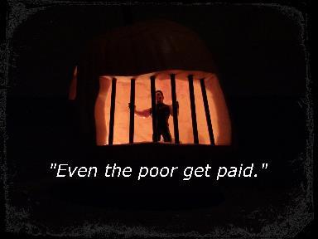
“And you’ve just learned why it won’t work. The Mod is pushing something that can’t succeed. That’s why their numbers are dwindling, and they have to commit bigger and bigger acts to get anyone to listen.”
“You’ve misrepresented us a bit there, my friend.”
Amanda put a hand on Jerald’s wrist to stop his automatic instinct as the door opened wide. “How so?”
Three men came through the smelly smoke of the fire. She recognized them all as elite breeders from missing persons rolls.
“We fight for equality, not for control. We do want a government, but it has to be like us, not like you.”
“You believe killing kids will gain that?”
“If they’re breeders, yes.”
“What happens when you remove the last breeder?”
“Humans can’t go extinct. We’re a plague that can’t be cured.”
Amanda shook her head at the indifference, the uneducated view. “I felt the same way most of my life.”
“What changed your view? You clearly aren’t one of us anymore.”
She drew her gun. “Let me help you understand.”
Jerald wanted to kiss her as the three bodies fell with stunned expressions. “I’ve never felt so close to someone!”
Amanda rolled her eyes. “Get a grip.”
Jerald laughed. “Let’s get out of here. Which way?”
Amanda pointed. “There’s always an escape hatch in case of fire.”
Jerald took that route without asking how she knew. He no longer cared about her past with old friends or those old goals. He only cared about the future.
The warehouse door shattered below them.
Amanda and Jerald kept climbing, getting onto the roof of the warehouse. They jumped and fled toward the insect-littered creek surrounding the building.
Amanda dropped down in the weeds.
Jerald landed next to her, knife in hand.
Voices sounded from all directions.
Amanda pointed toward the end of the district, whispering. “All farms are surrounded in the back by trees to prevent soil erosion and help hold in the water. We’ll climb one of them.” She took off running.
Jerald followed, scanning for witnesses. The Mod members were inside the warehouse, examining the scene of their latest crime, but it would only be a few seconds before they began to search.
Amanda picked up speed, leaving Jerald behind. She hadn’t known she could run this fast. It was difficult to swallow the laughter as she flew into the cover of huge fruit trees. She kept going, stopping when she reached the thick woods at the rear of the orchard.
Amanda turned around to scan for Jerald and found him limping through the fruit toward her. She didn’t rub it in that she had beaten him, sensing he was one of those people who might get sore about it. Instead, she wiped sweat off her neck and picked a tree.
Jerald had been busy staring at her ass. He didn’t care that she’d won the race. As she shimmied up a tall tree, he drew in a ragged breath, remembering that his body needed air. He followed her up slowly, trying not to dislodge branches that might give away their presence.
Amanda settled into the highest branch with thick coverage and leaned her head back. It was peaceful up here, despite the various insects that had been genetically engineered to propagate crops.
Jerald picked a piece of fruit and munched, trying to hear what direction the searchers were headed. There were a lot of shouts, but none were coming their way yet. He looked up at Amanda. “This is the first place I would look.”
Amanda shrugged. “Maybe they’re scared of the wildlife.”
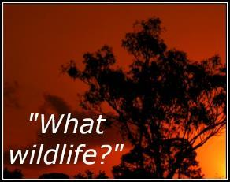
Amanda pointed to a hole at the base of their tree. “Many lifeforms were brought to the station, for various purposes. Some of them went to the science labs, but most ended up out here in the rural areas to keep the soil fresh and the crops growing. Some of those animals are very mean, to prevent the population from using them as a food source.”
Jerald sighed deeply. “We’re gonna die, again, right?”
Amanda giggled.
Both fugitives stilled as voices headed in their direction.
Amanda wasn’t surprised when the Mod members stopped at the edge of the orchard. From there, they couldn’t view through the tall trees, but she could see the two men clearly when the controlled air blew foliage aside.
Jerald held his breath, ready to fight.
The men moved away from the orchard and back toward the town, calling for searches of all homes and businesses.
Jerald got comfortable, assuming they would wait until it got dark before they snuck out.
Amanda surprised him by dropping from the tree and heading for the rear of the woods. When she began to circle around, he understood they were going to keep traveling even though there were searches ongoing.
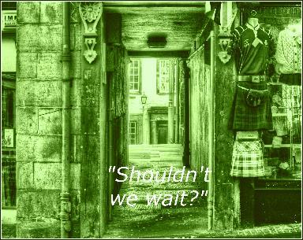
“We could, but it will be hard to hide missing limbs and blood. Some of the animals under our feet are going to wake up when the lab switches the station to evening. I don’t want to be their dinner.”
Jerald moved faster, taking a place on her heels. He didn’t relax for the rest of the trek through the woods.

The view of homes and neat shops added more proof to Amanda’s words as they emerged back into the populated area. Jerald noticed the houses were all wired for technology. There were no piles of garbage, of waste. This was better than the planet where he’d been raised.
Amanda led them out of the woods and toward the main road that led down the center of the industrial zone. The house she wanted was directly in the middle. There was no way to avoid it.
They entered the scientific zone without being noticed by the guards. It was shift change. They blended into the crowd.
Jerald didn’t acknowledge the town witnesses, but he kept an eye out for security and Moderation members.
Amanda went to the only house with a fence around it and rang the leaf-covered buzzer. While she waited, she leaned against the gate and scanned. It looked as though Eden Station was doing fine. Some of the buildings had fresh paint or renovations, with scaffolding still in place or in the middle of being put up. It seemed as though the industrial area was going through a boom.
The speaker beeped at them.
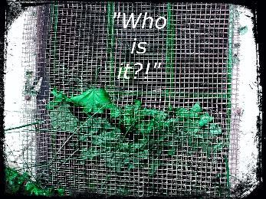
Amanda pushed the button and leaned in to whisper something Jerald wasn’t able to hear. A few seconds later, another buzzer sounded.
The gate clicked open.
The fugitives hurried inside, but it was obvious their presence was not going to be a secret. More than two dozen wealthy people were now staring, pointing, muttering.
“We’ll probably have to fight to get out of here.”
“I know.” Amanda led them to the main door of the small one-story house that was surrounded by a large yard of unkept blue grass. Jerald was impressed and confused once again. He’d been told the wealthy lived extravagant lives too. It appeared nothing was true. I don’t know what to believe.
Amanda reached back and put a hand on his arm. She didn’t like his misery.
Jerald gazed at her hand, grateful. I can believe in the murderer. She’s too brutal to lie.
Amanda turned as the door opened, smile coming across her face.
The tall, bald man grabbed Amanda, hugged her.
Jerald stared. He hadn’t considered that Amanda would have people who missed her, except her ruthless family. He assumed this was an uncle or maybe a brother. It was common for families to be split up according to their status. Non-breeders were not welcome in the wealthy areas
Or so I was told. That may not be true either.
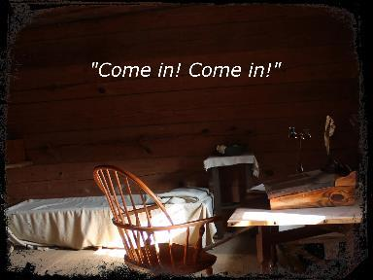
The man backed up to allow them inside a rundown home filled, floor-to-ceiling, with devices, electronics. Only a small living area was clear. Amanda recognized a few items, but not many. The scientist was doing things not taught on or off the station. Amanda had been elite. She should be familiar with this equipment, but she wasn’t. That meant it wasn’t legal.
Amanda pointed at Jerald. “This is my partner, Jerry. Jerry, this is Alex. He’s a station scientist and my father–my real father.”
Jerald gaped as the man shook his hand, then pointed toward a table.
“I was about to have tea. Join me.”
Amanda nudged Jerald toward the rickety table and chairs, then took a seat across from Alex. She studied his movements, his delighted but nervous expression. After being betrayed, she couldn’t help the suspicion. His quick peeks at windows weren’t helping.
“I guess you have a lot of questions.”
Amanda snorted. “Yeah. I assume the Mod is getting ready for another attack on the towers. They’ve lost all the battles since my trial. Do you know why?”
Alexander shrugged. “Once your mother took over communication for the Mod, she was no longer allowed to share details with me.”
“Why did my mother leave you? Does she still have a soft spot for you? Will she spare you?”
“I loved your mother, but not the Moderation Army that rules her every waking thought. I believe she married your stepfather so the Mod would have a way into the towers. As for emotions, I don’t know. I haven’t spoken to her in years.”
Amanda wasn’t sure if she believed him or not, but it didn’t matter. She had to have help. “I need you to recalculate the trajectory on the asteroid headed for HOP-28. Send it somewhere harmless.”
Amanda’s father frowned. “Why would I? It was a council decision to remove that planet.”
“Did you know Amanda was there?!” Jerald was angry again.
Alexander nodded. “That was very sad. There was nothing I could do about it. I don’t have a say in council matters or trials. I wasn’t even allowed to visit when she was here.”
“So you just let her die?!” Jared stood up. “We have to get out of here.”
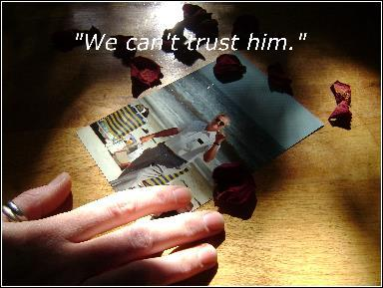
To everyone’s surprise, Amanda rose and followed Jared toward the door.
“Wait!” Alexander jumped up and grabbed Amanda’s arm. “Take this.” He handed her a communication drive that she shoved into her pocket.
He pointed to the rear of the home.
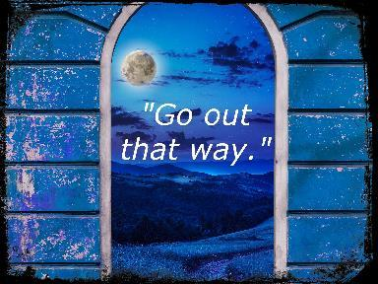
Voices sounded outside. The gate buzzer echoed.
“Let us in! You are harboring two dangerous fugitives!”
Alexander opened the main door. “Wait! That’s not–”
Laser fire erupted, hitting the thin walls of the house, piercing them.
“No!” Amanda ran to her father, who had crumbled onto the floor. Around them, laser fire blasted into the house in rapid succession.
Jerald huddled over Amanda and her father, trying to protect them with his body.
Alexander pointed a bloody hand toward the back of the house again. “Get out!”
A loud whistle sounded.
Jerald grabbed Amanda’s arm and dragged her toward the exit, kicking and screaming.
Something large and heavy slammed into the front room of the house and bounced. Hissing sounds echoed.
Jerald shoved Amanda out as the house exploded.
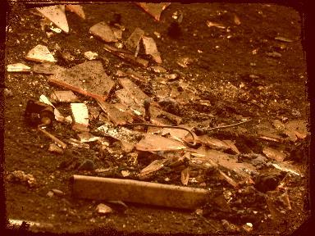
Amanda stood up in the smoke, trying not to cough. She considered their situation for a few seconds, then pulled her gun. She swung around to face Jerald. “I need a new body.”
Voices and shouts rang out from all directions. A loud alarm began to blare from the street pole nearby. They were about to be surrounded and captured. Jerald slowly drew his gun. “Together?”
Amanda nodded, lifting her weapon. “We’ll do it on two.”
Jerald made sure his aim was perfect and began to count. “One.”
She smiled, lending comfort. Dying was never easy. “Two.”
Guards came around the side of the house in time to see them fire and fall.
They hurried toward the scene. “The fugitives are dead.”
“Cancel the alarms and searches.”
Moderation members watched from the growing crowd as security fired a shot into each head. Jonathan stared at the bodies, then the burning house. When he swung around and headed back toward the poor district, his men followed. Amanda was dead. Any information she’d had wouldn’t be sold to the enemy now.
One of the security men waited until no one was looking and began searching the bloody bodies for loot. This was the best part of his job. Cain found the information drive in Amanda’s bloody pocket and slid it in his own before standing up to notify the morgue transportation crew.
A few feet away, two very new wealthy people watched the excitement with blank expressions and tense bodies. Amanda had asked that they be brought back instantly to continue on. She and Jerald had watched the security guard steal the information drive. As he headed to his next assignment, the two new people followed him. They needed to know whatever was on that drive. The enemy didn’t.

The End of Episode Five
What would you like to do now?

Read this episode again
Check out Episode Six
Connect with the author on FB
Read a full-length book by this author
Thank you! Have a wonderful week!
Angela White

Eden Station Map

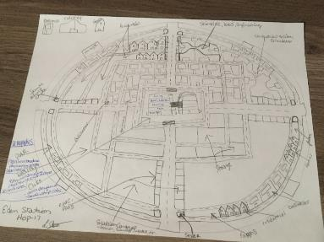

Contact the Author

Facebook:
https://www.facebook.com/authorangelawhite/

Email:
cloudninepublications@yahoo.com

Blog:
http://authorangelawhite.weebly.com/blog

Website:
http://authorangelawhite.weebly.com/

