HOP-17
Episode Four

Title: HOP-17
Episode Four
Length: 24 pages
Author: ©Angela White
ISBN#: 978-1-945927-54-6

All rights reserved worldwide. No part of this publication may be replicated, redistributed, or given away in any form without the prior written consent of Angela White.

TOC

Episode Four
Chapter Two
Episode Five Details

Episode Four
”I think I can stomach your story now.”
Amanda blanched. She dropped the ration bar back onto the cluttered table between them. “No, you can’t.”

“Try me.” Jerald settled back against the hard chair of the stolen vessel, arms aching. The captain hadn’t gone down easy.
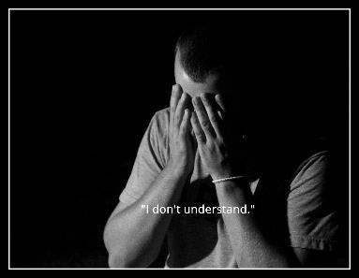
Amanda sighed. “I was born to die.”
“Of course not. You probably had parents who wanted you to have a long, happy life.”
Jerald blinked. “Well, yeah.”
She stared coldly. “What’s that like?”
“Amazing until someone you love dies of black lung from a lunar mine. Then it gets hard to survive without stealing.”
“That’s why you were dropped on HOP-28?”
“My mother was dropped. The tribunal didn’t care that she was pregnant. They dropped her one month before my birth.”
“How sweet. Little Jerry suckling at mommy’s breast.”
“Why are you so nasty?!”
“I was born to die! No one breastfed me or sang me lullabies. I was a member of the Moderation Army before I was born. In fact, if not for them, I wouldn’t have been conceived.”
“You’re different...”
“I was modified to be the perfect killer and I was, until I did it.”
“Start from the beginning and try to make sense. Your rambling drives me crazy.”
Amanda gazed at him in thoughtful silence, drawn to his sullen, suspicious nature. It matched her own.
Jerald crossed big arms over his wide chest, refusing to give in even if she got angry.
I like him. That’s dangerous.
“Why didn’t you leave the prison planet? You weren’t a convict.”
“I did. I was sent back on conspiracy charges, among others.” He glowered at her. “I tried to blow up a daycare in the breeder compound.”
“Interesting. Why only tried?”
Jerald was a bit taken aback by how she accepted each nugget of information without an emotional response. “Uh, I couldn’t follow through. One of the kids looked like me. It felt like suicide.”
“Why a daycare and not council homes?”
“I wanted the parents to live, to feel the pain of their murdered children–like my mom. She was stuck on that planet, with those monsters, just for stealing food. I wanted to steal their happiness too.”
“Stop talking now.”
He frowned. “Why?”
“We’re too much alike. I don’t need to hear it.”
”You killed your classmates.”
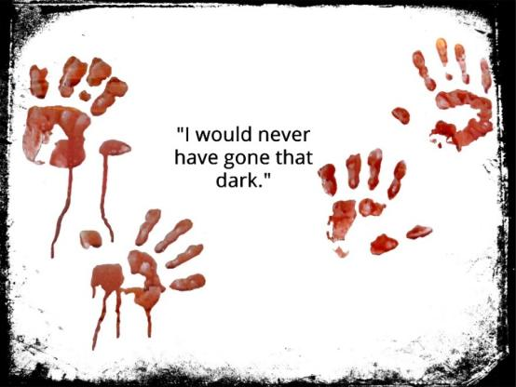
“Because I followed through, I’m worse than you are. I get that, but a daycare? That evens us up, as far as I’m concerned.”
“Killing is killing. Age and sex do not matter.”
“That proves my point about limits–you have none.”
Jerald was stricken. “Maybe you could teach me...”
“Why would I do that? I need you just like you are.”
“Then tell me your damn story!”
“Fine. My mother didn’t have a child. She birthed and trained a terrorist who grew up with the kids of the most powerful people in our universe. Her husband, the poor dupe, thought she loved him and their daughter, but my mother only wanted one thing from all those years–for me to die during a massive act of terror.”
Jerald’s lips thinned. “You chickened out.”
“In a way. I insisted on surviving to access rebels on the prison planet.”
“You’re still doing it, aren’t you?”
“No. My duty to my mother ended when I died. Now, I’m only loyal to myself.”
“Where was your dad while your mom ran around with the enemy?”
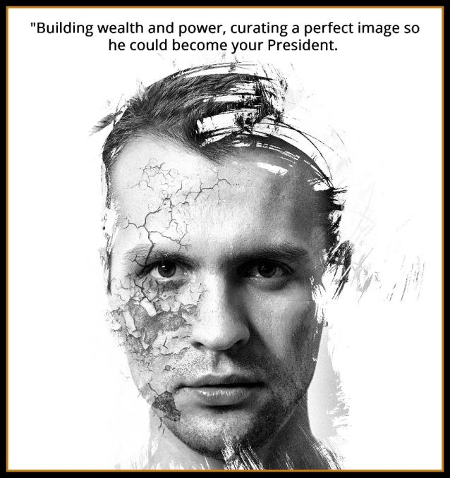
I rarely saw him.”
“Did he know?”
“Of course not. An illusion only works if someone believes it’s real. He loved us. He also liked my homeschooling. It made him look good that he had such a devoted wife. Like your mom, who pretended she wasn’t one of the monsters.”
“Yeah.” Jerald rose, stomach churning. “I’m going to check on the captive.”
Amanda had assumed he would spare any prisoners who’d already been on this ship and didn’t reply. She swiveled the captain’s plush chair to the screens and began accessing the files and logbook. “I didn’t even get to tell him about my training with the Mod. He’d really be upset over that.”
Amanda liked it that she was able to keep Jerald distracted enough so that their conversations always turned to him and his life. He didn’t need more knowledge about her. He already knew too much.
”Incoming alert.” The computer flashed a red box with huge writing.
Amanda used the computer to translate it. Her Russian was rusty.
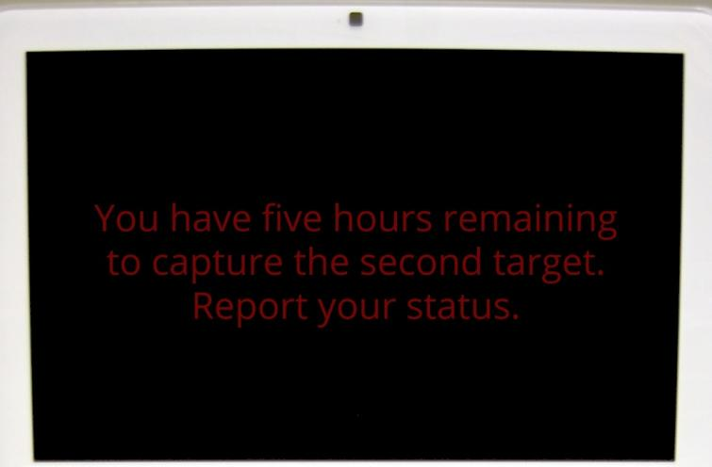
Amanda frowned. “Who was the other one? Surely you guys didn’t come here just for me.” She typed, bringing up the log. Her face paled as she read it.
Captured; Evelyn Roth.
Amanda jumped up and ran for the brig, not sure if she was already too late.

Chapter Two

“Stop!” Jerald tightened his grip on the beautiful breeder, knife against her throat. “One mother for another.”
Amanda stopped.
Evelyn didn’t fight the furious man. She stared at her daughter. She would know her blood anywhere by the bright eyes that couldn’t be changed.
“Why is she here?!” Jerald was beyond fury. He was on the edge of murder.
“The ship log said this is a bounty vessel. Both our names are on the list–our real names.”
“They came for you and your Moderation mother.”
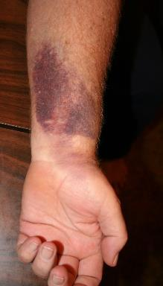
“Yes. Whatever deal you made at the fort was violated. We were betrayed.”
“But I never mentioned you!”
”Someone did.” Amanda eased into the brig, seeing four bodies of big Russian guards and then bruises on her mom’s arms that appeared fresh. “Let her go so we can find out where they picked her up and where they were headed after they got us both. The log doesn’t have that information.”
Jerald wanted revenge. Killing Amanda wasn’t satisfying because she wouldn’t stay dead.
Amanda shrugged. She dropped down into a hard chair to wait for his choice.
“You’ll just bring her back, right?”
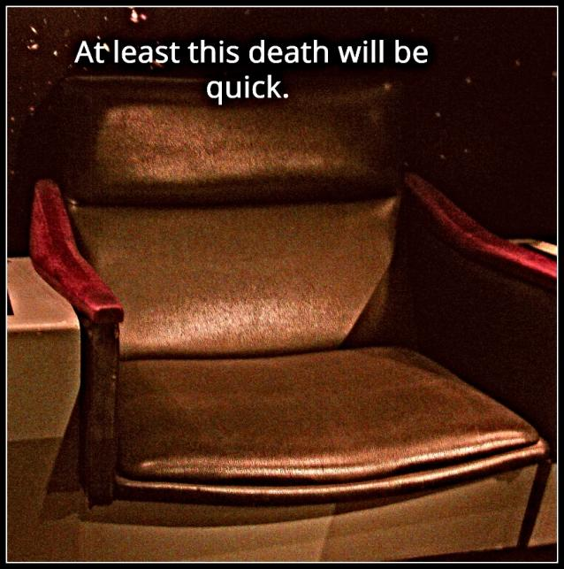
“I don’t have that power, but if I did, no, not now. If she fights with us, her final end could be a lot uglier.”
Jerald frowned.
Evelyn beamed. “I’m so proud of you.”
Amanda’s lips thinned; her nostrils flared.
Jerald waited for a tirade but there was only silence. He slowly lowered the blade as the need for vengeance faded into a tolerable throb. He hated Amanda. He needed to hurt her... I also want her, and she has to be willing. He sheathed the blade and shoved the prisoner back into the cell where she’d been hiding. I can slit her throat after she moans my name.
Amanda recognized the stare. She didn’t avoid it or encourage it.
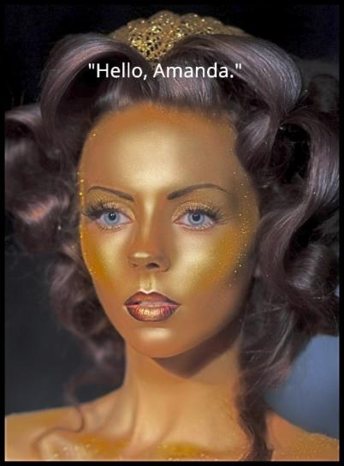
Jerald shuddered, barely stopping himself from offering her a deal. He left the brig, but only went into the hall so he could listen.

“I am proud of you.”
“That’s nice. You even sound genuine. Did you practice that, mother?”
“Of course.”
Jerald instantly loathed the woman. He slid back into the doorway to glower at Evelyn.
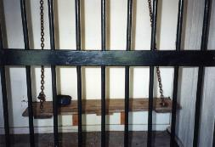
The females didn’t notice. They were already locked in eye-to-eye combat.
Jerald wasn’t surprised when Amanda won; Evelyn looked away, sighing.
“I won’t apologize for your life. I’m only sorry for the way you found out. I should have told you what you were being trained for, and why, long before you found that letter in my desk.”
“It wouldn’t have mattered. I would still hate you for making me live a lie.”
“Then why did you stop your boyfriend from killing me?”
Because you want it. You want to escape the guilt that older age is gifting you with, but I want you to live forever and feel it every second.” Amanda stood. She waved at the cell. “Go to sleep. If you don’t, he’ll make you.”
Evelyn went to the cot and settled down. She did want an end to her pain, but she didn’t want to die.
Amanda left the brig, bumping Jerald out of the way. “Lock that cage.”
Jerald did, wondering what would happen next. Would Amanda leave her mom on the ship or try to take her along for the invasion of Eden Station? Neither of those felt like good ideas.
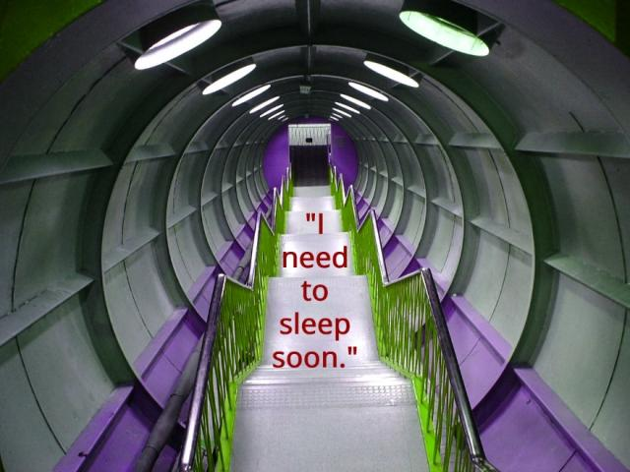
Jerald followed Amanda.
Amanda kept walking. She went to the captain’s quarters and shot the door panel to open it. She dropped down onto the dead man’s bed.
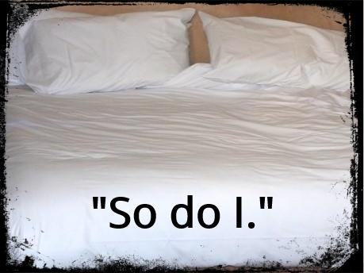
Jerald froze as she stretched out.
Amanda grimaced. She rolled over, giving him her back. “Just get it over with so that pause in your brain will go away...rapist. That’s really why you were stuck on that criminal planet.”
“Yes.” Jerald climbed into the bed and yanked her over by her arm.
Amanda stared at him, not sure if she would kill him at the moment of his pleasure or right before he got there.
Jerald groaned and rolled off her. He collapsed on the bed, muttering.
Amanda went to sleep.
Jerald grumbled a bit longer, then fell into a restless slumber at her side.

Evelyn watched them on the monitor from the captain’s chair. The cell key hung on a chain around her neck. She opened a line of communication and began typing, eyes never leaving the young couple.
The plan is almost finished. We will reach our final reward in three hours. Will you be there?
Evelyn studied Jerald as she waited for an answer, trying to figure out why Amanda had chosen him as her protector from all the rebel males on HOP-28.
Evelyn jumped as the reply beeped at her.
We are in place. Is your daughter ready to do her part for the future?
Yes. She’s still one of ours.
Good. No contact is recommended. Goodbye and good luck.
The same to all of you, my friends.
Evelyn erased the communications, put the chair back into the position it had been in when she sat down, then hurried back to the cell to lock herself in. “I’ve given everything to the cause. Amanda will do the same.”

Jerald woke with hair in his mouth. He spit it out, head turning to find Amanda on his chest.
She looked up, eyes bloodshot. “What?”
Jerald felt his heart grow. It hurt. He grimaced as he patted her shoulder. “Go back to sleep.”
Amanda did, head thumping to his chest. Her light snores echoed a few seconds later.
Jerald left his arm around her and shut his eyes, no longer aroused by lust. The need to protect Amanda was stronger. I’m changing.
Sleep reclaimed Jerald. In his dream, he held her close and tried to keep the Creator from taking her back.

Amanda woke next. She did a fast scan of screens and dials, then of the man holding her so tight she couldn’t breathe. Amanda shifted, loosening his hold, then fell back out, soothed.

Evelyn also slept, but not deeply. When the ship began to slow, she unlocked her cell to be ready for the action. Turning her daughter over to the guards on Eden Station would not be met with a warm reaction. Amanda would react as she’d been taught. Evelyn expected blood and screams. If those didn’t come, then she would worry.

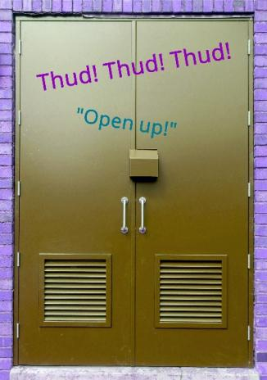
Amanda and Jerald were shoved into alertness by pounding on the door.
“Come out with your hands up!”
Jerald flew out of the bed, blade in hand.
Amanda grabbed his arm and pointed up.
Jerald leapt and grabbed the vent. It came loose in his panicking grip, sending him back to the floor.
Amanda walked up his back as he stood, then leapt into the hole.
Bodies slammed against the door.
Jerald jumped and followed Amanda into the darkness.
Below them, guards burst through, shattering the door.
“In the vent!”
Amanda hurried to the emergency pod section and kicked the vent through. She dropped down.
“Over here.” Jerald led her to a double pod and shoved her into the cold seat. Heavy steps sounded outside the door.
Jerald secured the pod and activated the launch sequence, picking a fast target.
The pod launched just as the guards broke down the door. It blasted out into space.
Evelyn stared. “That wasn’t part of the plan. Where is she going?!”
Evelyn left the pod bay and went to the bridge, ignoring the angry, confused Eden security force she had summond. “I need to send a message. Get lost.”
The guards went back to the transporter, muttering.
Evelyn contacted her army.
We may have a problem.
She watched the pod on the tracking screen, concern growing when it went to the one place she never wanted Amanda to go.
Where is your daughter?
I think she went home.
The computer beeped a few seconds later with an order Evelyn wasn’t sure she could follow.
Kill her.
Evelyn didn’t respond.

The End of Episode Four
What would you like to do now?

Read this episode again
Check out Episode Five
Connect with the author on FB
Read a full-length book by this author

Thank you! Have a wonderful week!
Angela White

Contact the Author

Facebook:
https://www.facebook.com/authorangelawhite/

Email:
cloudninepublications@yahoo.com

Blog:
http://authorangelawhite.weebly.com/blog

Website:
http://authorangelawhite.weebly.com/

